Nama : Ratu Sondang Elishabet Sidauruk

Program : Accelerated Machine Learning

Mentor : Erwin Fernanda

1. SELECT FirstName, LastName, Address, State

FROM customers

WHERE State IS NOT NULL

ORDER BY FirstName

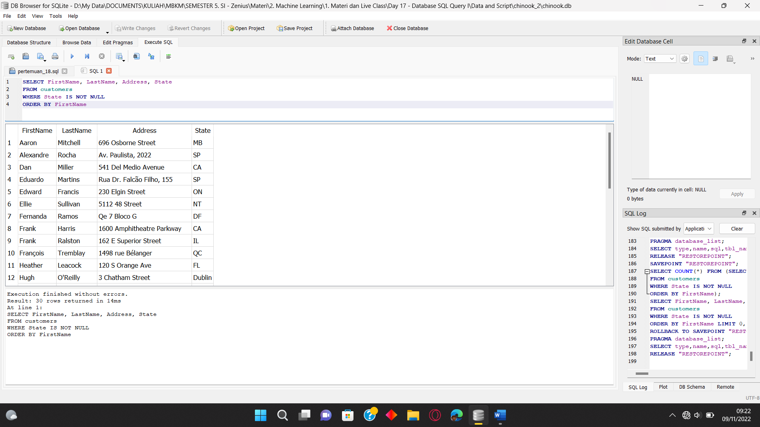

1. SELECT CustomerId, Phone, Email

FROM customers

WHERE Country = "USA"

LIMIT 5

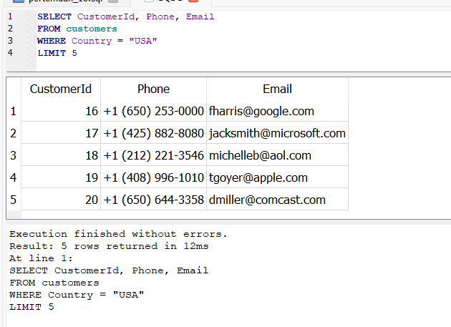

1. SELECT CustomerId, InvoiceDate, total

FROM invoices

WHERE Total >10

ORDER BY Total DESC

